PRESIDENT’S OFFICE

REGIONAL ADMINISTRATION AND LOCAL GOVERNMENT
DODOMA REGION

FORM FOUR PRE MOCK EXAMINATION

013 GEOGRAPHY 1

Time: 3 Hours April 2021

Instructions

- This paper consists of three sections A, B and C with a total of 10 questions.
- Answer all questions in section A and B and any two (2) questions from section C.
- Map Extract of MKOMAZI (sheet 109/1) is provided.
- Non programmable calculators and other authorized materials are not allowed in the examination room.
- Write your examination number on every page of your Answer booklet(s).

SECTION A: (15 MARKS).
Answer all questions in this section.
- For each of the item (i) – (x), choose the correct answer from the given alternatives and write its letter besides the item number in the answer booklet provided.
- What are the social economic advantages of reserved forest to societies?
A. Lumbering B. Tourism C. Agriculture D. Mining E. Forestry
- Mr. Jackson Chacha decided to construct a map with each 2 centimeters representing 8.4 kilometers on the ground. What is a representative fraction scale did he put on his map?
A. 1:840,000 B. 1:420,000 C. 1:420,000 D. 1cm: 84km E. 2:8.4
- The seasonal fluctuation of a river in its volume is known as:-
A. River capture B. River Basin C. River profile D. River Rejuvenation
E. River Regime
- One of the items is not components of the solar system
A. Sun B. Planet C. Plateau D. Meteoroids E. Asteroids
- The permanent movement of people with animals in search of water and pasture is called:- ____________
A. Nomadism B. Transhumance C. sedentary pastoralism D. Seasonal grazing E. permanent grazing
- The factor that does not affect the water supply is __________
A. Superstition works B. Rapid Population C. Water Pollution D. Low supplying technology E. Poor government support
- What is the local time of town ‘S'(65⁰E) when it is noon at another town ‘R’ (40⁰E).
A. 10:40am B. 06:40am C. 1:40pm D. 1:40 am E. 12:40pm
- Life expectancy is _________
A. Expected years someone can live B. Ability to afford health cure
C. Ability to become rich D. To live without diet problem E. living without facing wars
- Features on topographical maps are presented by __________
A. Form lines and sport heights B. Sport heights and optical square
C. Hill shading and scales D. Piece of paper and compass E. None
- ____________ is the last stage in a research process
A. Data collection B. Data presentation C. Report writing D. Piloting E. Research design
- Match the items in list A with the responses in list B by writing the letter of correct response beside the item number in the answer booklet provided
LIST A | LIST B
I. A layer of igneous intrusion which is vertical that cut across bedding planes of the crustal rock  II. A dome-shaped igneous intrusion with a flat floor  III. Is the largest intrusion of all igneous intrusion  IV. A column made up of very viscous lava and which stands above the general ground like pillar.  V. Is a funnel-shaped volcanic depression which forms at the upper end of a volcanic | A. Phaccolith  B. Batholiths  C. Caldera  D. Crater  E. Lacolith  F. Lapolith  G. Plug domes  H. Lava plateau  I. Dyke  J. Sill

SECTION B (55 MARKS).
Answer all sections questions.
- Use the map extract of Mkomazi to answer the following questions.
- Find the bearing and direction of Kwamiali grid reference 923803 from Mkomazi grid reference 980868
- With reasons explain three economic activities that seem to be taking place on the given map.
- Express the scale of the map as statement scale in meters.
- State the (2) types of transport observed from the map
- Calculate the area covered by the seasonal swamps.
- Carefully study the following information in the table below that shows the number of students at Luco Secondary School and then answer the questions that follows:
FORM I | FORM II | FORM III | FORM IV
60 | 125 | 90 | 35

- Present the number of students in each class in percentage
- Draw a pie graph and represent the data provided
- Define pie graph and outline the advantages of using it
- Mr. McMillan is a chemist; he is interested to conduct a research about beverage to see the best drinks for human consumption. His plan is to consult consumers who were directly involved in the consumption and visit other scholar’s written documents for more information
- What will be the best research approach for his study
- Name the main sources of data for his study
- Suggest the question of his research
- Mention other six possible sources of research problem for the similar study
- What is chain surveying?
- In short, explain the stages of conducting chain surveying
- Mention two advantages and disadvantages of chain surveying
- Carefully study the following photograph and answer the question that follow

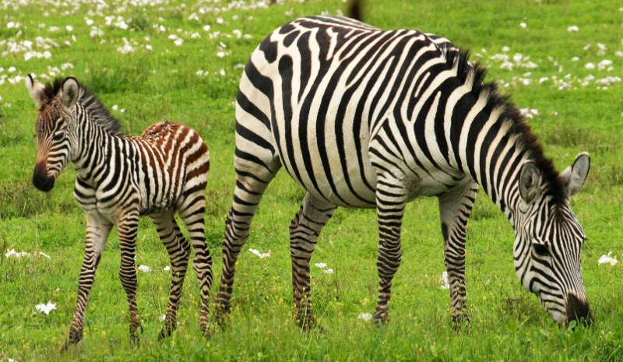

- With evidence name the type of photograph
- What are the environmental problems that might affect the area
- What are the solutions can be taken to overcome in ( b ) above
- Name three areas where the photograph might be taken
- With reasons determine the time at which the photograph was taken

SECTION C (30 MARKS).
Answer (2) two questions from this section.
- “The living environment in Tanzania is suffering at the expense of man's activities.” With the supportive six points, prove this statement
- Explain six ways of improving the industrial base in East Africa.
- We have several sectors to nurture Tanzania development, and one of those sectors is agriculture. Support the above statement by providing six points.

